**URL:** <https://www.legislation.gov.uk/new/2024-11-15?requested=2024-11-16>

In the Advanced Search, start by entering the keywords either in the Title or in the Keywords in content text field indicated in box 1. Ensure to filter the type of content by selecting the option indicated in box 2.

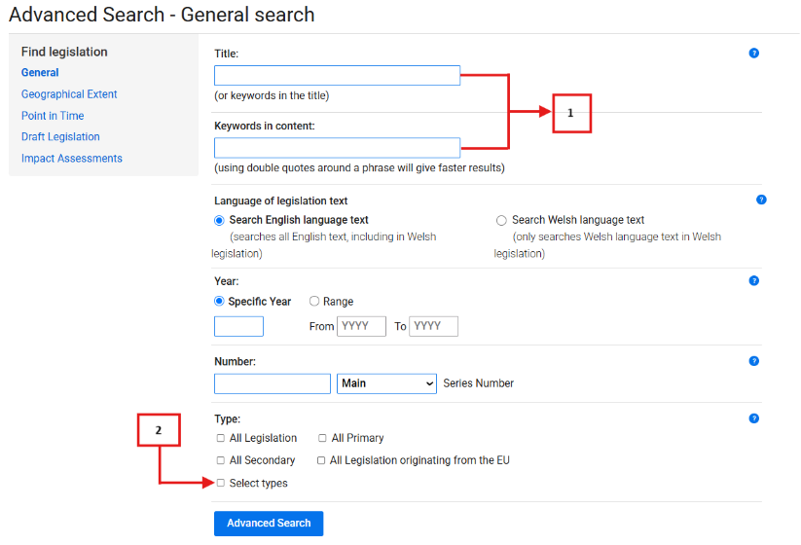

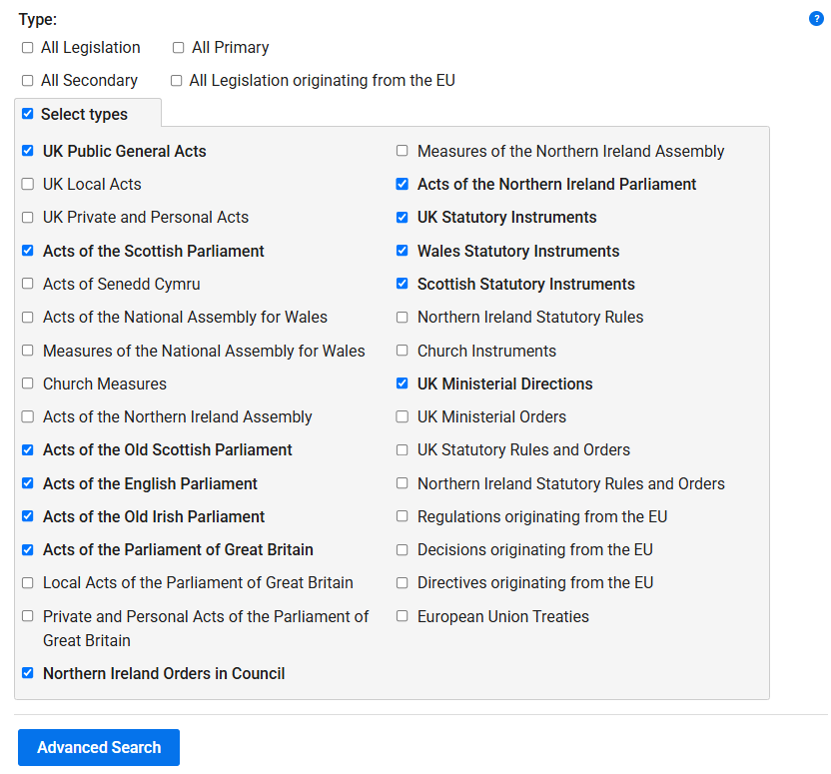  
 In the results page, only the following metadata can be extracted:

* Original Title
* Source Link
* Type of Regulation

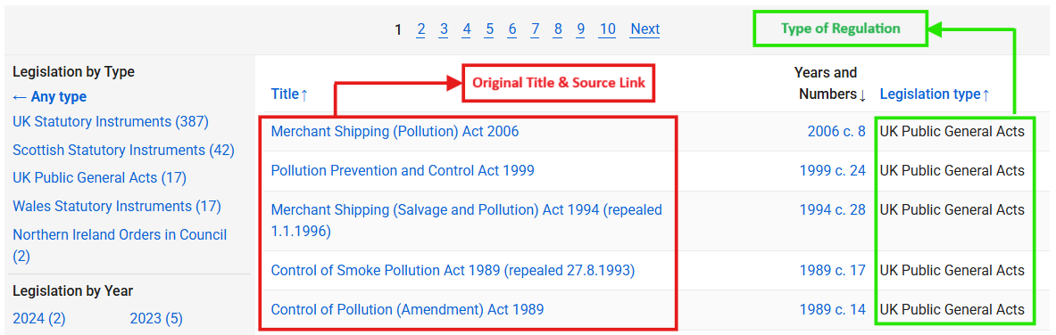

To extract the Date of Adoption and the Entry into Force Date, just access the specific legislation. The Date of Adoption and Entry into Force are usually found in the Introductory Text and in the Commencement section from the table of content. If not visible in the Commencement section, entry into force date will be left blank.

In Acts, the Date of Adoption is the date when the Act received Royal Assent, while the entry into force is the date below the document icon.

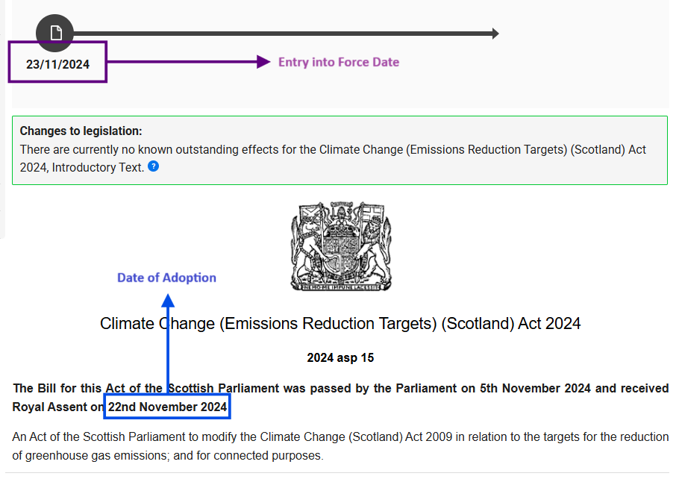

In Statutory Instruments, both dates are readily available. Date of Adoption is the date when the legislation was made while the entry into force is the date commencing ‘Coming into force’.

